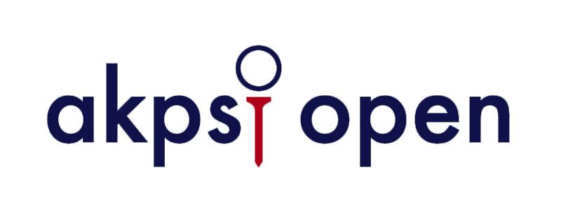
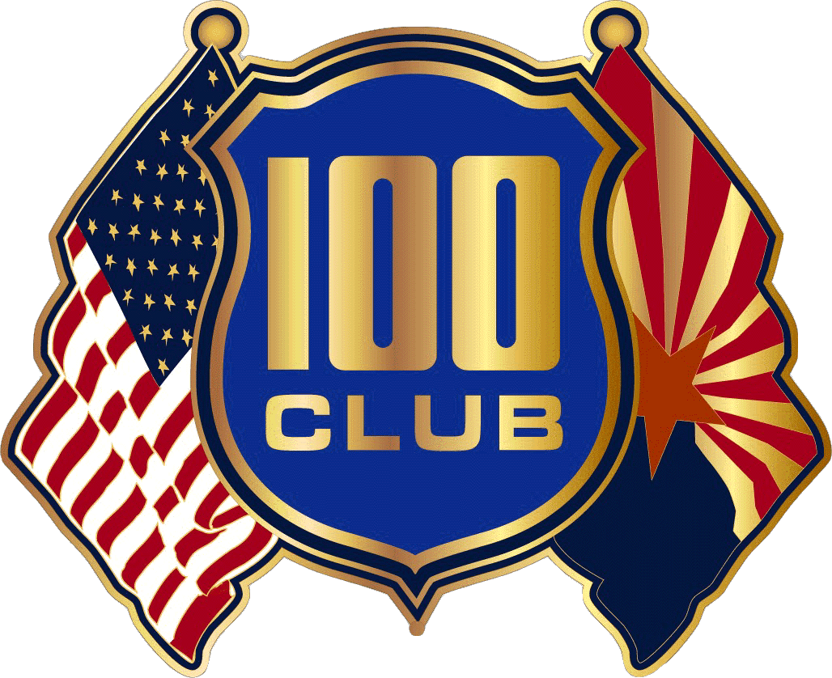
Basic Sponsorship $100

- Company name and logo displayed in program and concluding ceremony
- Company name and logo on the AK Psi Open website

Hole Sponsorship $200

- Company name and logo displayed at the hole tee box
- Company name and logo displayed in program and concluding ceremony
- Company name and logo on the AK Psi Open website

50-50 Putt Sponsorship $400

- Company name and logo located around putting green during and after tournament
- Company name and logo displayed at the hole tee box
- Company name and logo displayed in program and concluding ceremony
- Company name and logo on the AK Psi Open website
- One spot for a player in the AK Psi Open

Range Sponsorship $500

- Company name and logo displayed at the driving range before the tournament for warm up
- Company name and logo displayed at the hole tee box
- Company name and logo displayed in program and concluding ceremony
- Company name and logo on the AK Psi Open website
- One spot for a player in the AK Psi Open

Par 3 Sponsorship $1000

- Display products at presentable tent at a selected par 3 location on the course
- Present a challenge to each competitor for the tournament
- Company name and logo will be at tee box for par 3
- Company name and logo displayed in program and concluding ceremony
- Company name and logo on the AK Psi Open website

Title Sponsorship $2500

- Name displayed on all materials for AK Psi Open
- Company name added to the title of the tournament
- Company name and logo in program and concluding ceremony
- Logo and banner on putting green and driving range in premium position
- 2 complimentary foursomes, including breakfast and lunch
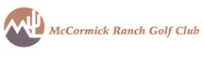
David Lewis
Tournament Co-Chairman
515-231-7432
djlewis6@asu.edu
Sean Miller
Tournament Co-Chairman
520-249-0536
stmiller@asu.edu

